**Year 12 General Biology Task 7: Biodiversity Test**

**Answer Booklet**

**Name: ______________________________________________**

**Date: _________________**

Time Allocated: 60 minutes

Weighted: 18%

**Multiple Choice Short Answer Extended Answer Total**

**/26**

**/37**

**/10**

**/13**

**/8**

**/10**

**/44**

**SECTION 1 MULTIPLE CHOICE ANSWERS**

Please circle the correct answer for each of the multiple choice questions below.

|  |  |  |  |  |
| --- | --- | --- | --- | --- |
| **1** | a | b | c | d |
| **2** | a | b | c | d |
| **3** | a | b | c | d |
| **4** | a | b | c | d |
| **5** | a | b | c | d |
| **6** | a | b | c | d |
| **7** | a | b | c | d |
| **8** | a | b | c | d |
| **9** | a | b | c | d |
| **10** | a | b | c | d |

**Multiple Choice Questions 10 Marks**

1. What is biodiversity?
2. Its environmental science.
3. Refers to the varieties of life on earth.
4. Diverse ecosystems.
5. Climate measurements.
6. Globally, the leading cause of biodiversity loss is?
7. Invasive species.
8. Pollution.
9. Poaching and overharvesting.
10. Habitat change and loss.
11. Which of the following describes a species that will soon be gone if nothing is done?
12. Threatened.
13. Endangered.
14. Invasive.
15. Extinct.
16. Which of the following best describes why bioindicators are used:
17. Gives insight to which elements are present.
18. Screens the health and quality of the ecosystem.
19. Screens how many species are present in the ecosystem.
20. Identifies the pH found in the environment.
21. The example of polar bears losing their habitat as arctic ice melts is often used to highlight the severity of climate change. Many scientists argue that fluctuations in climate are natural, while others argue that such extreme fluctuations are the result of human impacts. Either way, there is no denying the reduction of ice in the Arctic will affect more than just polar bears. What are some other impacts?
22. Increased sea levels due to ice melting; loss of migration routes; an increase in penguin populations.
23. An increase in tsunamis; changing migration patterns of many birds and fish; a drop in sea levels.
24. Interference with the lifecycles of significant numbers of species; genetic changes as species adapt to new climatic conditions; increased coral bleachingTop of Form.
25. An increase in coastal mountain rainforests; fluctuating sea levels; increased coral bleaching.
26. A keystone species is best described as:
    1. Organism which is underpopulated.
    2. Organism which is overpopulated.
    3. Organism with a small effect on the environment.
    4. Organism with a large effect on the environment.
27. Top of Form

Bottom of Form

1. Which of the following best describes the biological species concept?
2. Based on capacity for two species to coexist.
3. Based on capacity for species to interbreed.
4. Based on capacity for species to breed.
5. Based on capacity for species to survive harsh environmental conditions.
6. Top of Form

Bottom of Form

1. Which of the following is an example of an invasive species:

a) Rabbits

b) Cane Toads

c) Foxes

d) All of the above

1. How many species are estimated to be living on Earth?

a) between 10,000 and 100,000.

b) between 500,000 and 1 million.

c) between 1 and 10 million.

d) between 10 and 50 million.

1. Which of the following is an example of a keystone species:
2. Star fish
3. Elephants
4. Wolves
5. All of the above

**Short Answer Section 26 Marks**

* 1. Define biodiversity and give two reason why it is important in a sustainable natural ecosystem. (3 marks)

* 1. Identify and describe 4 human impacts on biodiversity. (8 marks)

* 1. Identify 2 biomes in Australia and describe them and the species you would find in them. (4 marks)

* 1. Explain the relationship between species biodiversity of an area and the availability of abiotic factors/resources. (2 marks)

* 1. List and describe two restorative practices that mining companies could do with closed mine sites to help reintroduce biodiversity to an area. (4 marks)

* 1. Identify an example of a species for the following in Australia: (3 marks)

a) Migratory Species

b) Keystone Species

c) Invasive Species

* 1. Discuss how habitat degradation affect the migratory species of birds in Australia

(2 marks)

___________________________________________________________________________

___________________________________________________________________________

___________________________________________________________________________

___________________________________________________________________________

___________________________________________________________________________

___________________________________________________________________________

___________________________________________________________________________

___________________________________________________________________________

**Extended Answer Section 8 Marks**

**18.** Western Australia is one of the world’s most diverse hotspots in terms of biodiversity.

**Identify** and **describe** the 4 main factors driving biodiversity in Western Australia.

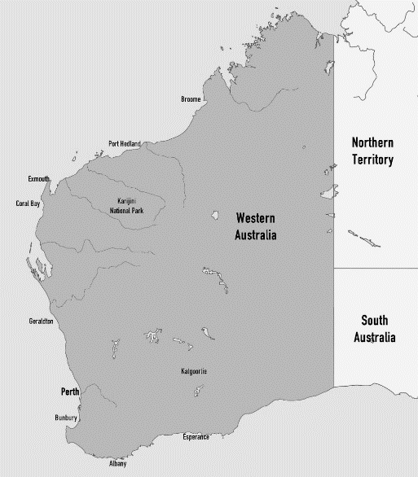

**End of Assessment**